ASP.Net Core Final Project Report:

1)Login Screen

2)After logged in Employee list will display with not requested status

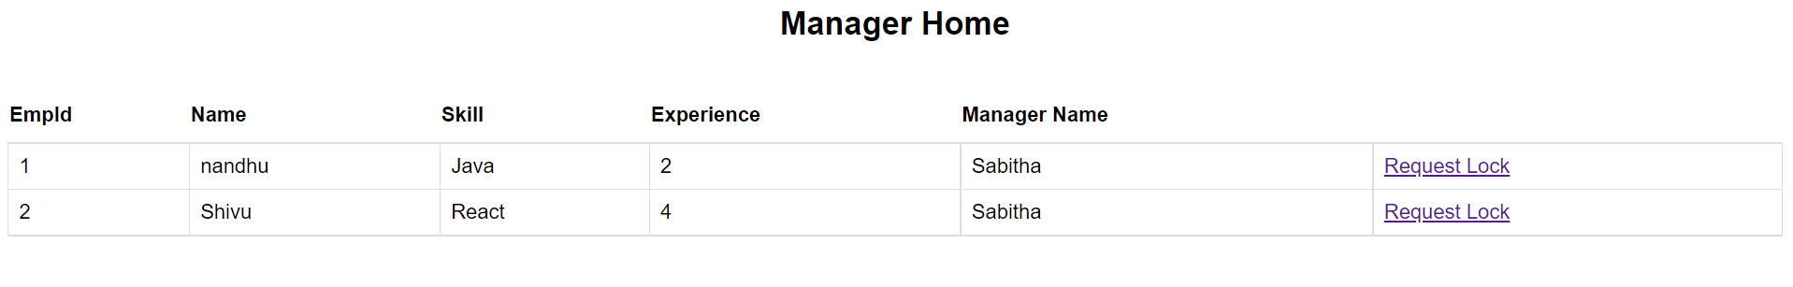

3)Manager can be able to request the employee by clicking the request lock button.

4) WFM Login will display the list of soft locks with the awaited approval status.

5) if wfm manager can able see the basic details of request

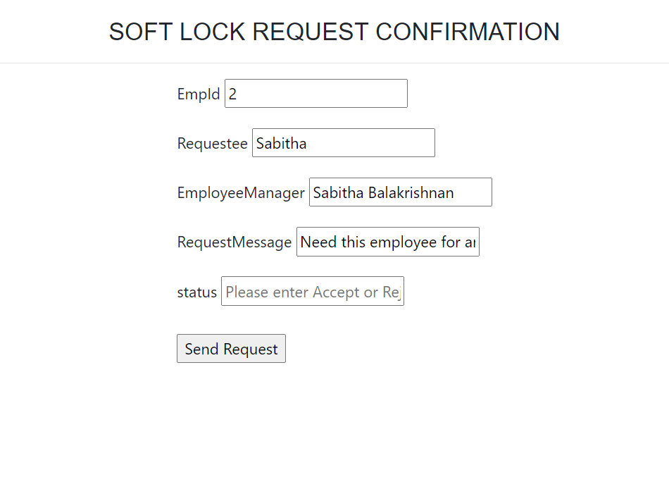

7)If wfm manager accept the employee by adding the accept message and clicking the send request button.